Think Central
https://www-k6.thinkcentral.com for K-8 Science Fusion and K-5 Go Math!
(6th-8th grade Math Log In: https://my.hrw.com)
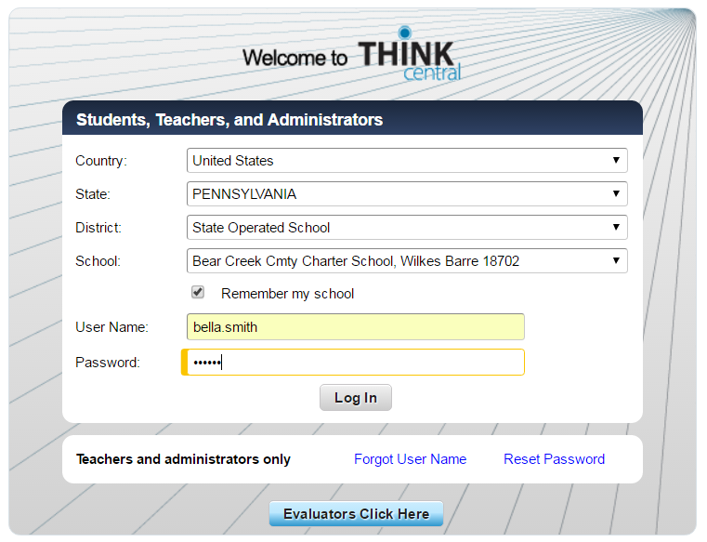
Initials and 4-digit lunch code
first name.last name
Access textbooks and resources from home!

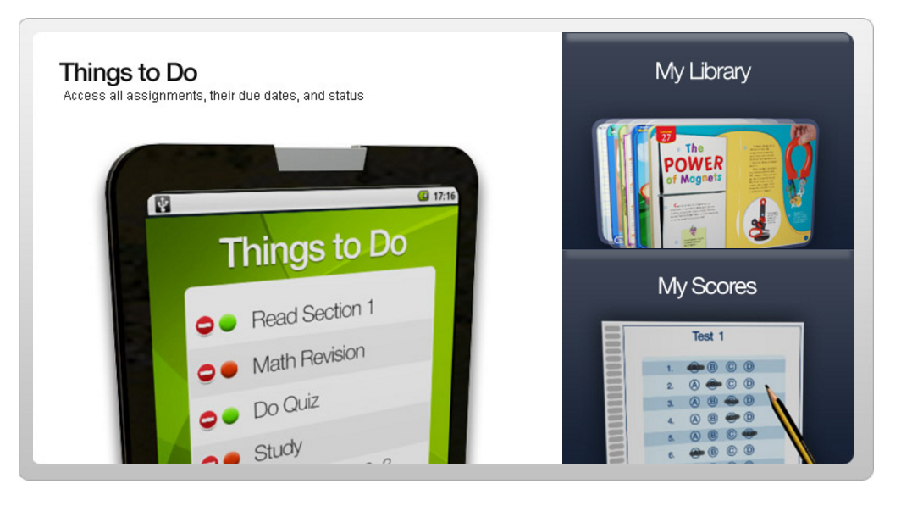

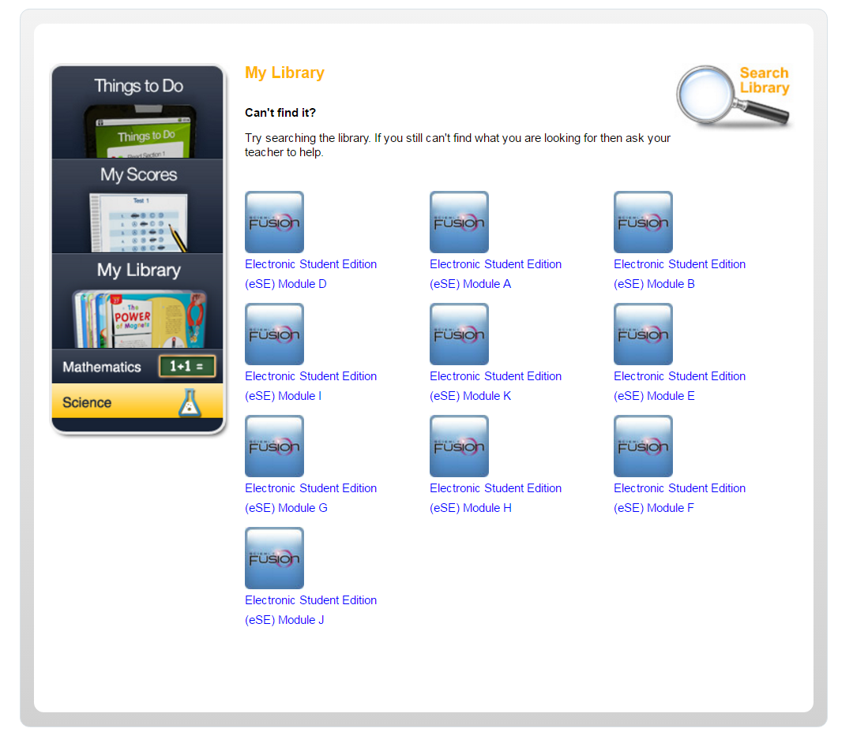
Choose your subject
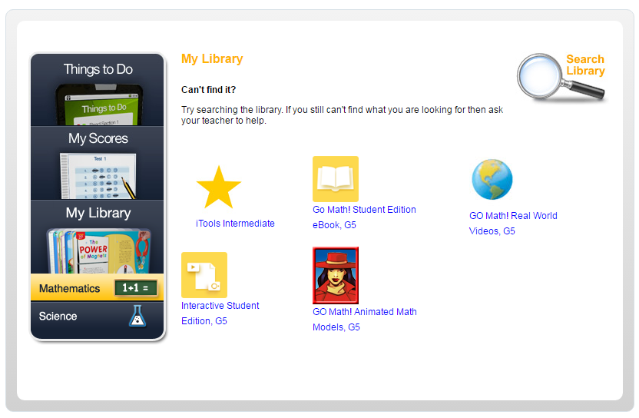
Student Edition Math Book
Choose your subject
Access Your Materials!
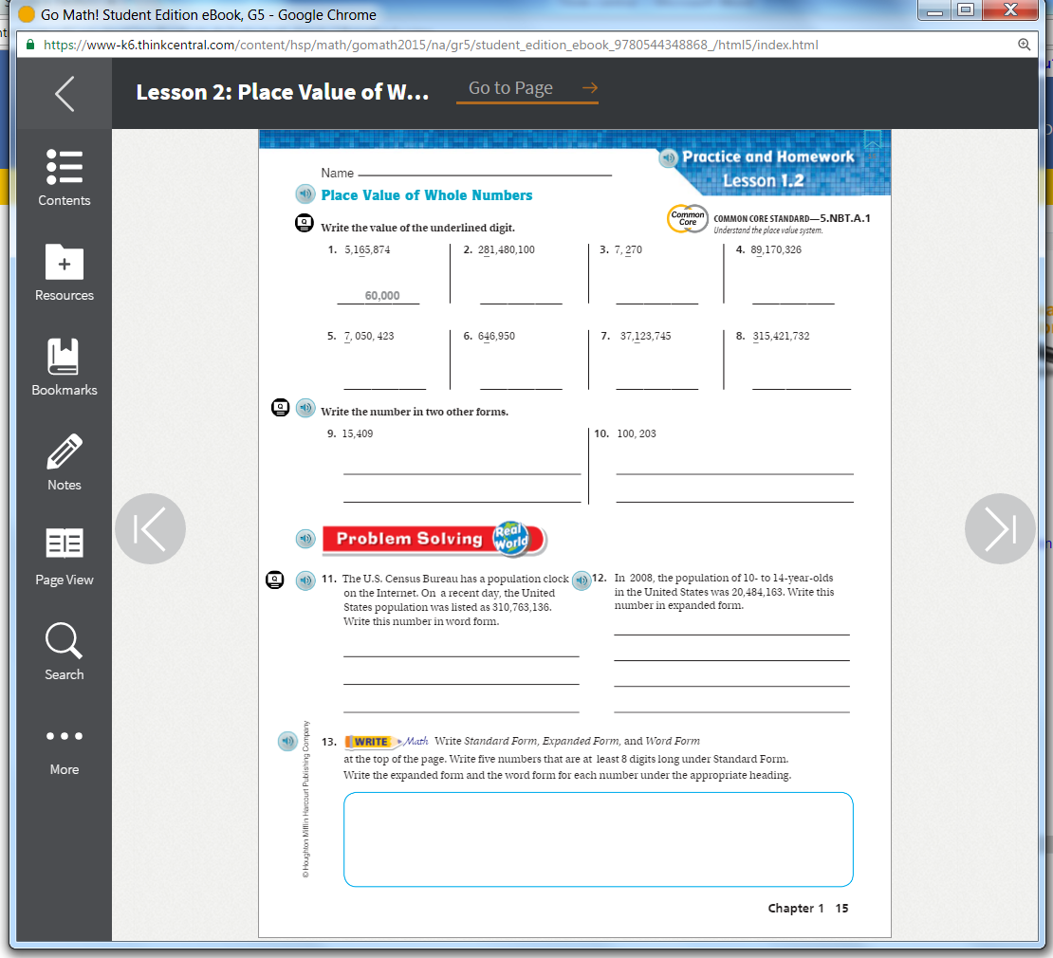

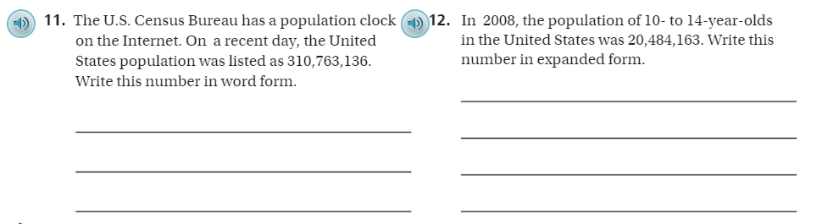
Click the speaker to hear the question read aloud!

